Creating a Static Website with S3

Step 1: Create a Bucket
- Search for S3, click on S3
- Click on bucket
- Provide a unique bucket name. Your bucket name should reflect your domain name if you plan to use one (eg www.tech.com)
- Make sure to uncheck and disable Block all public access and acknowledge that the bucket will be publicly accessible, then leave the rest as the default settings.
- Click Create Bucket
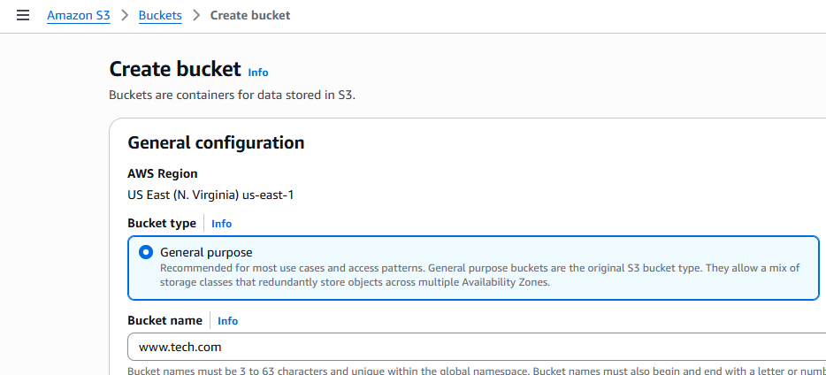
Uncheck
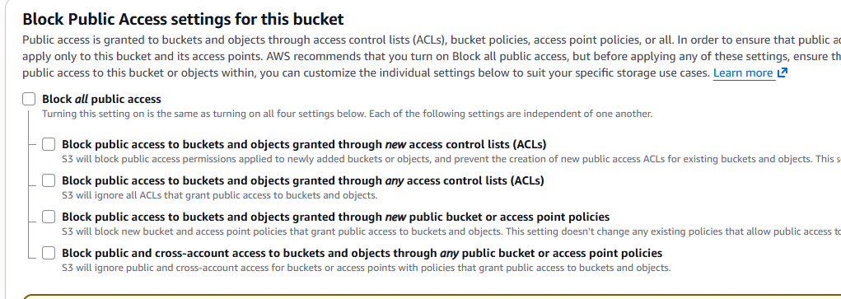

Step 2: Upload index.html Files to Your Bucket
- Click Upload.
- Click Add files to select your website files ( create one index.html files in your desktop and upload it)
- Click Upload.
Step 3: Make Your Bucket Content Publicly Accessible
- Go to the Permissions tab of your bucket.
- Click Edit in the Bucket policy section.
- Enter a bucket policy that grants public read access to your website files.
{
"Version": "2012-10-17",
"Statement": [{
"Sid": "PublicReadGetObject",
"Effect": "Allow",
"Principal": "*",
"Action": "s3:GetObject",
"Resource": "arn:aws:s3:::your-bucket-name/*"
}]
}
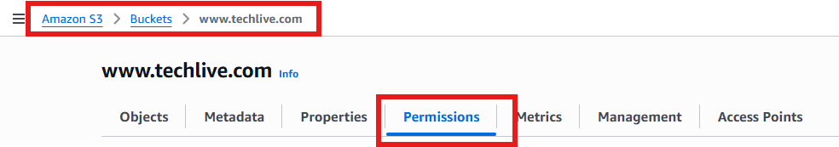
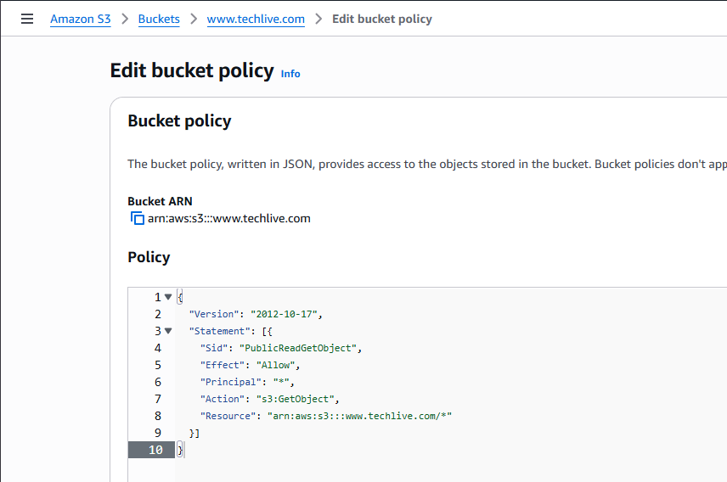

Make sure to add your bucket name in line 8 as show
Save changes

Step 4: Enable Static Website Hosting
- Click on bucket, click the Properties tab.
- Scroll down to find the Static website hosting option and click Edit.
- Select Enable.
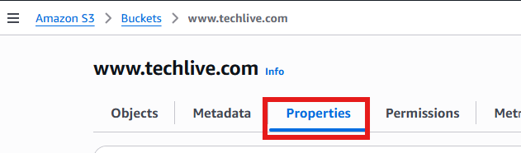
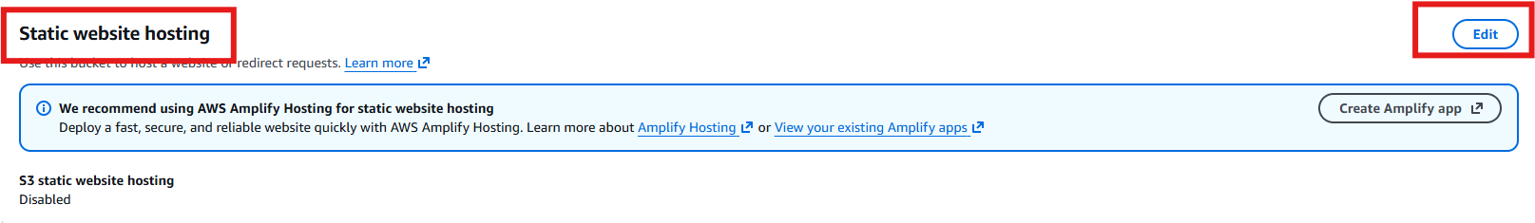
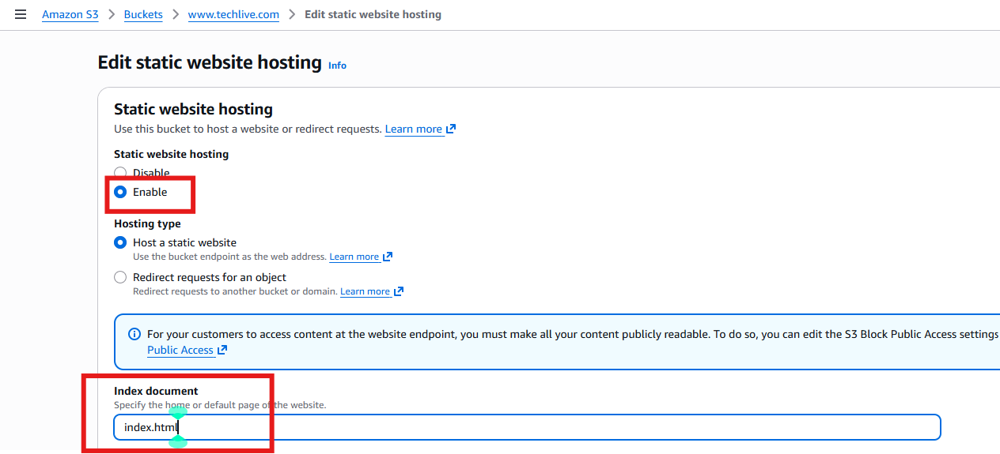

Save Changes

Step 5: Test the Website URL
Go back to the Properties tab and find the Static website hosting section.
You will see a Bucket website endpoint URL (e.g., http://your-bucket-name.s3-website-region.amazonaws.com).
Copy and paste the URL into your web browser to test your static website.
